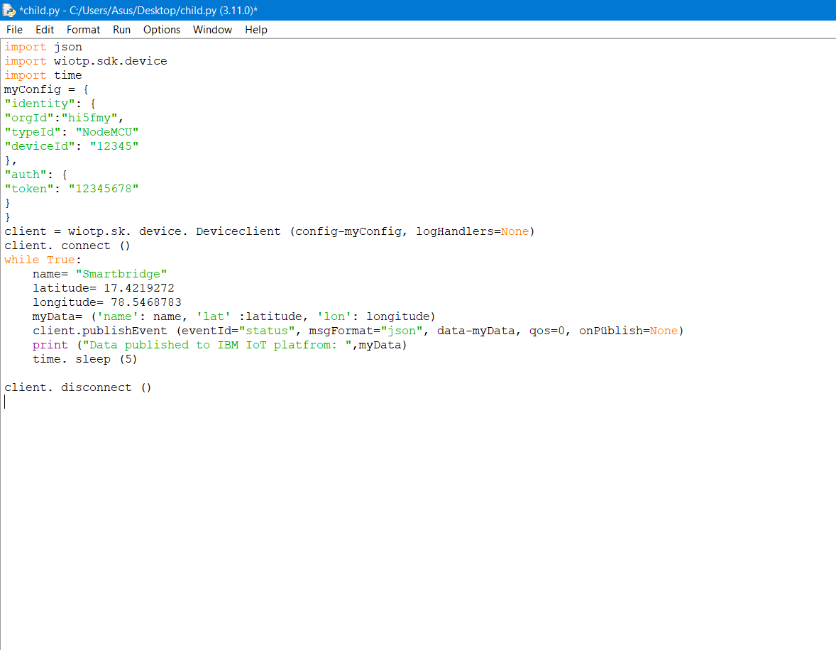Develop Python Script

|  |  |
| --- | --- |
| Project Name | Project - IoT Based Safety Gadget For Child Safety Monitoring & Notification |
| Maximum Marks | 2 Marks |